

**/**



**Ibrahim abdo**



***Minority***

***~~R~~***

***~~e~~***

***port***

▪

Pre

-

crime units

▪

Precognition

The crime system

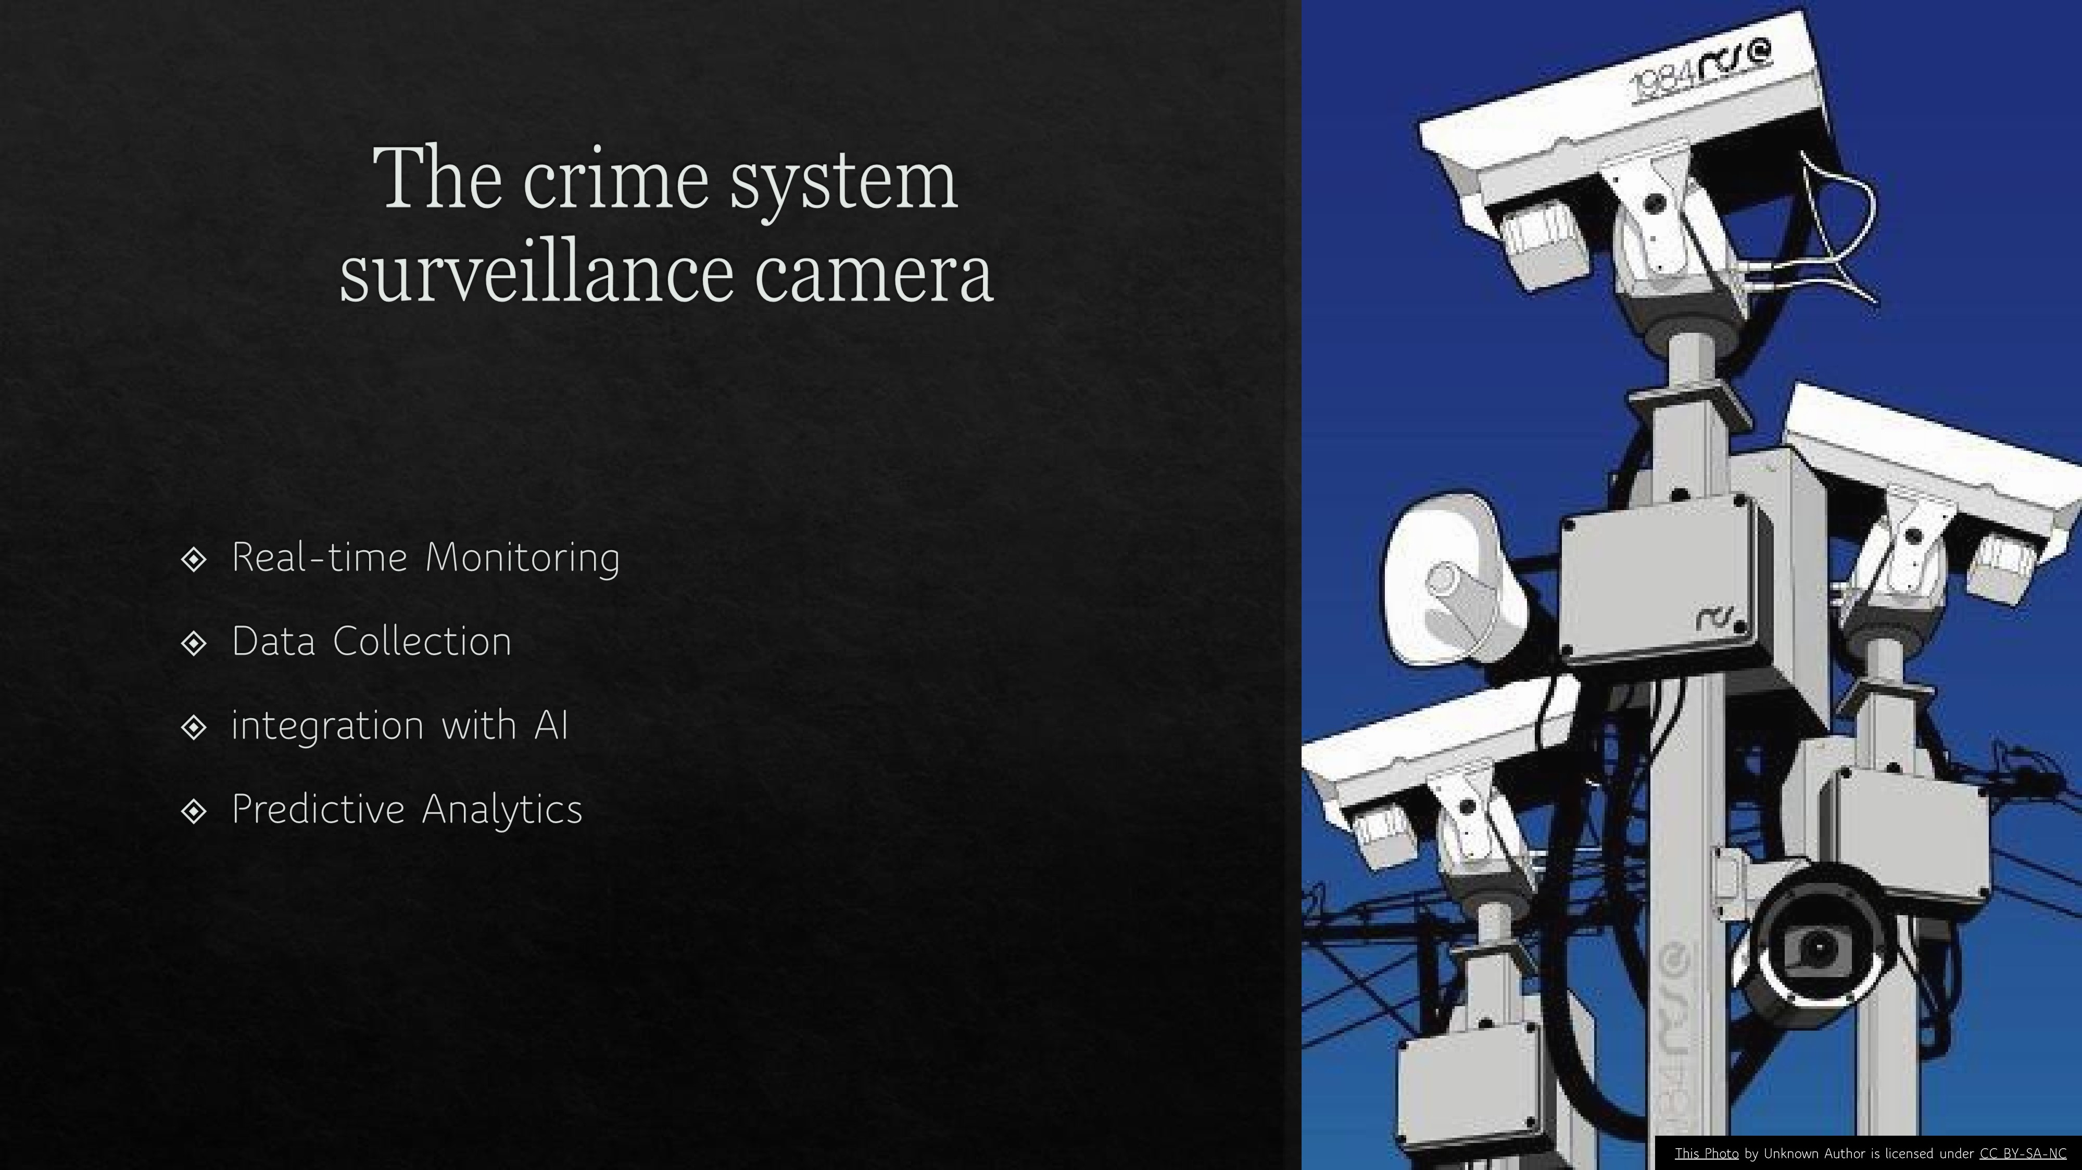

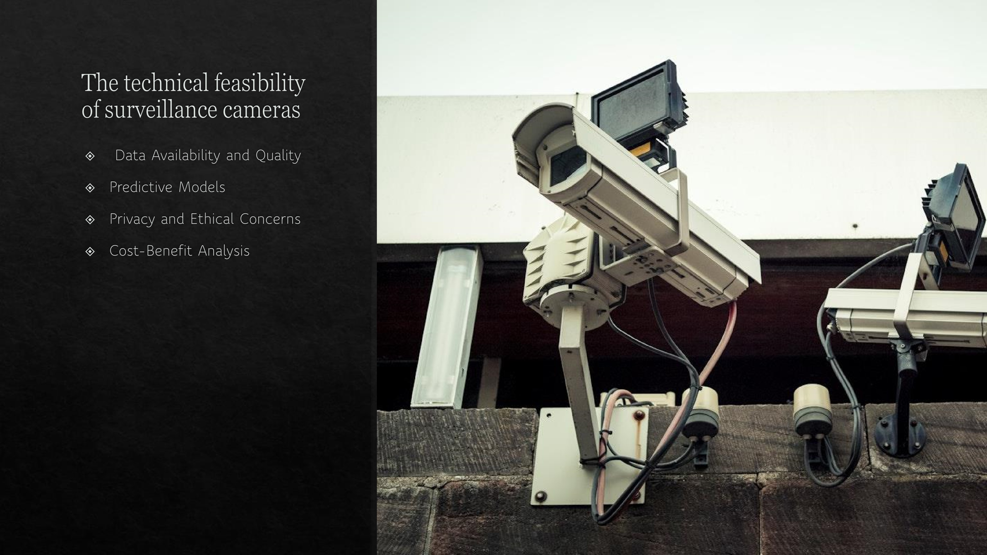

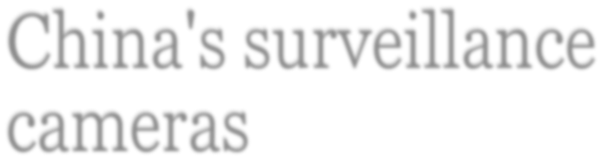

China's surveillance



cameras



CHINA HAS 1.4 BILLION



PEOPLE AND AN



ESTIMATED 176 MILLION



PUBLIC AND PRIVATE



SURVEILLANCE CAMERAS,



INCLUDING ON EVERY



BLOCK IN BEIJING

.



Domains and Subdomains in AI

The

domains

that

are

related

to

the

surveillance cameras

are

:

•

Perception :

the surveillance cameras uses

computer vision subdomain in :

•

face recognition

•

Action recognition

•

Object recognitio

n

•

Learning

:

as

the

surveillance

cameras

uses

machine

learning

subdomain

in

:

•

Deep neural network : in recognizing

patterns and human behaviour

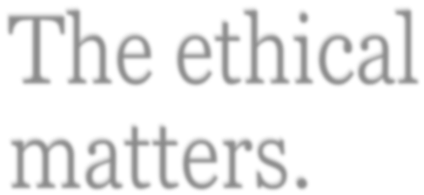

l

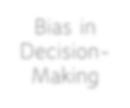

Bias in

Decision

-

Making



Privacy

Concerns

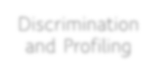

Discrimination

and Profiling



Job

Displacement

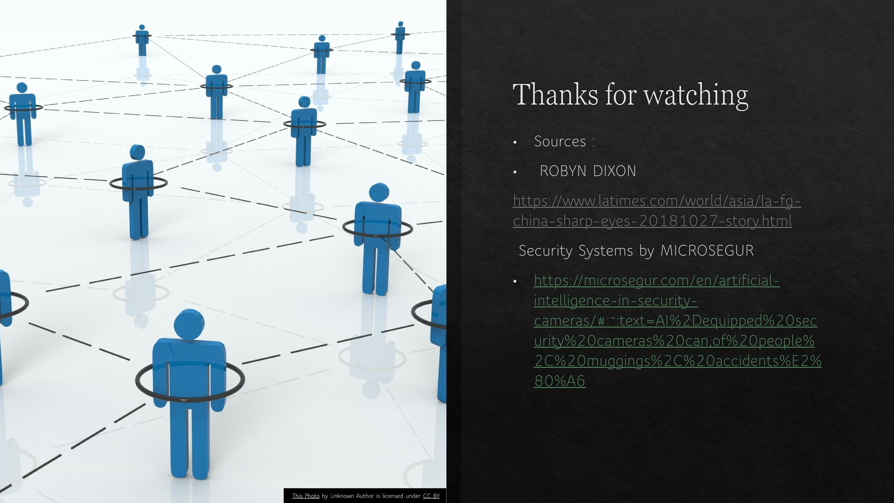

Thanks for watching.

Resources:

R. Kakadiya, R. Lemos, S. Mangalan, M. Pillai and S. Nikam, "AI Based Automatic Robbery/Theft Detection using Smart Surveillance in Banks," 2019 3rd International conference on Electronics, Communication and Aerospace Technology (ICECA), Coimbatore, India, 2019, pp. 201-204, doi: 10.1109/ICECA.2019.8822186. keywords: {Conferences;Videos;Security;Weapons;Real-time systems;Proposals;Surveillance;artificial-intelligence;computer-vision;deeplearning;theft-detection;video-analysis}.

Chen S, Berglund E, Bigdeli A, Sanderson C, Lovell BC (2008) Experimental analysis of face recognition on still and CCTV images. Proceedings of the 2008 IEEE fifth international conference on advanced video and signal based surveillance, pp 317–324.

Chen X, Flynn PJ, Bowyer KW (2005) IR and visible light face recognition. Comput Vis Image Underst 99(3):332–358

Jobin, A., Ienca, M. & Vayena, E. The global landscape of AI ethics guidelines. Nat Mach Intell 1, 389–399 (2019). https://doi.org/10.1038/s42256-019-0088-2